AR ___ | HELP WEST CAMPUS: A resolution encouraging density, affordable student housing and business in West Campus while protecting its over 100 year eclectic, historic, UT-Austin student heritage and character by utilizing fair, long-term, sustainable development practices.
1. WHEREAS:  (Boundary) | West Campus is a geographic region traditionally and historically demarcated by Lamar Boulevard to the West, 17th Street to the South, Lavaca and then Guadalupe north of Martin Luther King Boulevard to the East and 29th Street to the North. (Page 4, Figure 1.)
2. WHEREAS:  (No voice) | West Campus contains primarily students and residents presently suffering from “Not In My Backyard” or NIMBY troubles due to no formal representation of their interests and long-term goals unlike the surrounding neighborhoods that may have law firms to defend them. (Page 5 and 6.)
3. WHEREAS:  (Anti-  competitive) | When drafting their University Area Overlay (UNO) rezoning plan, business interests excluded West Campus residents, homesteaders and other businesses; however, those same business interests—last year—deprived their competitors many of the profit maximizing rezoning waivers they now plan to impose on West Campus. (Page 3, Texan Article; Page 4, Table 1.)
4. WHEREAS:  (Tacit  collusion) | Business interests may set aside about 10 percent of units as affordable housing primarily to qualify for about $500,000 in fee waivers—potential, public, student, taxpayer dollars best used for safety, lighting, sidewalks and green space—but then massage the affordable housing qualification equation to rent a 2 bedroom, 2 bathroom unit for $1300 or more per month. (Page 4 and 5.)  http://www.dailytexanonline.com/news/619702.html
1. (Boundary) THEREFORE BE IT RESOLVED that before continuing forward with UNO rezoning at its present frenzied pace, the public servants within the City of Austin plus its elected or appointed officials—together—provide better disclosure, transparency and especially reconciliation with its West Campus neighborhood students, residents, homesteaders and taxpayers who have been thus far tactically shut-out of the UNO rezoning process through City mistakes like failure to properly notify well in advance of a City process that has been in the planning for the past one or two years.

2. (No voice) THEREFORE BE IT FURTHER RESOLVED that the West Campus NIMBY issues be quickly corrected prior to UNO going before City Council by simply incorporating seven standard neighborhood-friendly zoning amendments: (1) Allow for tree-lined, wide sidewalks with lots of night lighting, traffic controls and a pedestrian/bicyclist/student friendly street and neighborhood design. (2) Allow for density by keeping the current 60 ft height precedent and letting density slowly evolve over the City's 50 year plan. (3) Don't provide unfair entitlements to big money developers by waiving current compatibility standards to the detriment of West Campus. (4) Don't provide harmful profit incentives by waiving current parking standards to the detriment of West Campus residents, employers and students. (5) Do not waive Traffic Impact Analysis (TIA) standards, to prevent a traffic, parking and accident war zone in West Campus. (6) Preserve existing green space and open space standards rather than waiving them for big business. (7) Require in-district, multiply-clustered, riparian parkland/wetland within the highest density zones at a ratio of 5 acres high density to 1 acre parkland/wetland (Page 7. Some clusters or 1 acre minimum wetland pocket parks must be between Rio Grande and Guadalupe.).

3. (Anti-competitive) THEREFORE BE IT FURTHER RESOLVED that UNO business interests adhere to the same compatibility and height standards they forced upon their competitors outside West Campus and that there be a written agreement insuring new West Campus developments have 1 bed/bath rents in the $400's and 2/2 rents in the $800's for those new developments to qualify as affordable student housing and obtain huge six-figure fee waivers.

4. (Tacit collusion) THEREFORE BE IT FINALLY RESOLVED that since “everything’s bigger and better in Texas,” the UT-Austin student body expects and deserves wide open spaces and genuine housing choices—for example, to live in dorm-like, high density, high rises or less dense, dispersed, open-spaced, Riverside-area apartments—and that these preferences—or real competition and consumer choice—must be protected by maintaining current shuttle bus route schedules well into the future. If schedules are not maintained or UNO is not amended prior to going before City Council, then the UT-Austin student body requests that the City of Austin please provide a detailed accounting of how much student and West Campus homesteader, taxpayer dollars were spent to subsidize, develop, market, advertise and/or promote the private, commercial construction interests of UNO developers at the expense of West Campus including but not limited to time spent by City staff, workshop expenses, mapping and related documentary expenses plus a tab delimited, addresses text file containing all the multiple, past, mail-out and notification efforts regarding the rezoning overlay changes to West Campus and the surrounding neighborhoods.

Authored by:  Sponsored by: | Suran Wije, BA/BS; UT Student; 2003 SG Students with Disabilities Agency Director.  Hope Garcia, Liberal Arts Representative; Gus Perez, Natural Sciences Representative.

Notes, Quotes and Definitions:

1. “Trusts and monopolies are concentrations of wealth in the hands of a few. Such conglomerations of economic resources are thought to be injurious to the public and individuals because such trusts minimize, if not obliterate normal marketplace competition, and yield undesirable price controls. These, in turn, cause markets to stagnate and sap individual initiative.” http://www.law.cornell.edu/topics/antitrust.html
Dear Student Assembly:

Please excuse my absence due to Red Cross volunteer swim commitments. This flyer is to publicize my grassroots effort to prevent a Tragedy of the Commons, http://members.aol.com/trajcom/private/trajcom.htm , by adding seven fair and friendly amendments to UNO, http://www.svj1.com/WestCampusCommonsTableFig1.htm . Article below is fortuitous:

Daily Texan - Opinion - Issue: 01/23/04 - Villas will be a tight squeeze - By Jennifer Litz (Daily Texan Columnist)

The contractors have finally been given the green light to commence the construction of the Villas at Guadalupe along Hemphill Park. Every student who can't claim heir to a backyard money tree would do better to contemplate the shrubbery between 27th and 29th streets, the proposed site for the ultra-dense, primo-expensive housing venture.

Belabored voting was spurred by the controversy of the prospective buildings' measurements: The Villas will be something of a heifer. To draw in as many dollars or house as many students as possible, Villa proponents lobbied for the densest and thus most rarely used zoning plan available, Multifamily-6. With 68 apartments per acre, that's damn dense. Yet the discrepancy between close-to-campus housing and number of UT students is wide enough to justify such a zoning act close to campus. And building close to campus around pre-existing facilities combats urban sprawl. Most importantly, the inconvenient and environmentally hazardous drive across town being its alternative, the Villas project is a union that combines pragmatic urban planning and benefits to students.

Well, only if you consider ideals and not realities.

From the urban planner's perspective, keeping students squashed in a place near campus eliminates their need for a car, reducing traffic and pollution concerns. Attempting to exploit this contention, project consultant Mike McHone will provide a mere 395 parking spaces for the projected 500 students. He must not have a kid in college. We all know that insufficient parking isn't a call for students to lace up their tennies. It's a race rally, where the fittest engine and the sharpest turn gets the last parking space. Confirming the projections of concerned neighborhood inhabitants, the losers will continue burning fossil fuels slowly along the already heaving curbs of Guadalupe and surrounding streets until they find an unclaimed side of concrete. Lane arteries in West Campus and Hemphill already clogged? Prepare for the heart-attack.

Unable to access the cars they parked in some far-flung road, students can still walk to class as one of the conveniences of living close to campus. But such "perks" are literally hard bought. Denser housing may be less expensive to the builders, because more units per acre and smaller units are cheaper to erect, and many times, the city will provide discounts for such undertakings. Do Villas planners plan to pass on these savings, or pocket them as greater net return? With two- and three-bedroom units to range from $1,200 to $1,500 a month, it seems they chose the latter route. The exorbitant pricing of many existing apartments on West Campus makes a legitimate defense for the builders, and one which speaks about the final cause against the project - the danger of precedents.

If MF-6 housing is indeed erected on that "virgin site" between Hemphill and Guadalupe, what will it mean for other prospective builders? Will they be content, given the cheaper cost of building but greater return from eager tenants, with the current MF-4 zoning when they can exploit the latter? There are already rumors of another prospective MF-6 prospector waiting to pounce on the West Campus market and a win for the Villas is just the set of coattails he needs to ride into the neighborhood. And what then? Students will know that they are paying more to be crammed in tighter spaces, all for the mere gain of being able to walk to school. Inevitable tragedy will teach them the inherent dangers of packing many people in a small space.

Oodles of money going to the hands of those Villas "pioneers" who otherwise will have washed their hands of the whole matter will escape the tenants' view. But it will be quite clear to the profiteers, who will be convinced of the benefits of trading urban sprawl for urban beanstalk.

It is important to be alert that West Campus will become much, much worse (3 X Denser) than what’s described above as all the green/open space, parking and compatibility standards have been waived in the developer-drafted UNO plan (see Table 1 below). Moreover, the University Association Partners (UAP), forced past developers to abide by many of the following amendments, so it is hypocritical now for UAP to ask for harmful waivers unless all UAP wants is unfair profits at all costs.

The seven fair and friendly amendments to UNO are: (1) Allow for tree-lined, wide sidewalks with lots of night lighting, traffic controls and a pedestrian/bicyclist/student friendly street and neighborhood design. (2) Allow for density by keeping the current 60 ft height precedent and letting density slowly evolve over the City's 50 year plan. (3) Don't provide unfair entitlements to big money developers by waiving current compatibility standards to the detriment of West Campus. (4) Don't provide harmful profit incentives by waiving current parking standards to the detriment of West Campus residents, employers and students. (5) To prevent a traffic, parking and accident war zone in West Campus, don't waive Traffic Impact Analysis (TIA) standards. (6) Preserve existing green space and open space standards rather than waiving them for big business. (7) Require in-district, multiply-clustered, riparian parkland/wetland within the highest density zones at a ratio of 5 acres high density to 1 acre parkland/wetland. Please contact me, Suran Wije, if you intend to run for SG. 577-9453, suran3@hotmail.com
Table 1. FOLLOW THE MONEY: During the past year, vast tracts of West Campus real estate have been quietly sold or are pending sale to big box, big money developers who helped draft the City’s pseudo-fifty-year University Area Overlay (UNO) West Campus rezoning overlay plan.
Issues 1-9 | West Campus Harms | Developer UNO Benefits
1. Developer-drafted UNO West Campus rezoning overlay plan. | Intrinsic, eclectic Austin character will be bulldozed and permanently demolished. | Shut-out historic homes, families, residents, students, and small businesses from participating or interfering. No notice provided of UNO to them.
2. Hardin House, Madison House, Contessa, Univ. Gardens and/or about 15% of UNO highest zoned land quietly sold or pending sale. | Historic, environmental and grassroots concerns marginalized or alienated through secretive land deals. Additional large property big box assemblages likely. | Quiet land-grab and developer UNO control means competitive advantage over local, grassroots, Austin-based Green developers. Walmart-like tactics to encroach and bankrupt local businesses.
3. Skyscrapers up to 175 ft. | Iron Curtain blockade severs community. | Pack in students like sardines. Maximize profits.
4. Build on zero property line. | Existing homes jailed around 175 ft walls. | Waive current compatibility standards. Big profits.
5. No historic, environmental or big box shadow/no-sun analysis. | Intense commercial development adjacent to historic or smaller residential homes. | No sunlight, shadowed, smaller residences will diminish in value. Developer then can buy-out.
6. No Traffic Impact Analysis (TIA) | Traffic, parking and accident war zone. No adjusted benefits to aid traffic issues. | Waiver of current standards. Build however much desired without consideration for traffic impacts.
7. Waiver of green & open space. Little, if any, green or open space. | From nature friendly to concrete jungle. No chance for public parklands—ever! | No current standards means big profits. More concrete = more profits. Green space = less profits.
8. Waiver of parking standards when presently there’s no mass transit like lightrail. | No free or curb-side parking. Students isolated from bulk of City. No car = No viable jobs/shopping in West Campus. | Bigger profits for developer parking garages.  Developer charges students higher rents for cars and further maximizes monopolistic profit structure.
9. Affordable housing myth! | Poor residents and students further gentrified. Not pedestrian friendly. | Massage qualification equations to meet affordable housing standards and again maximize profits.

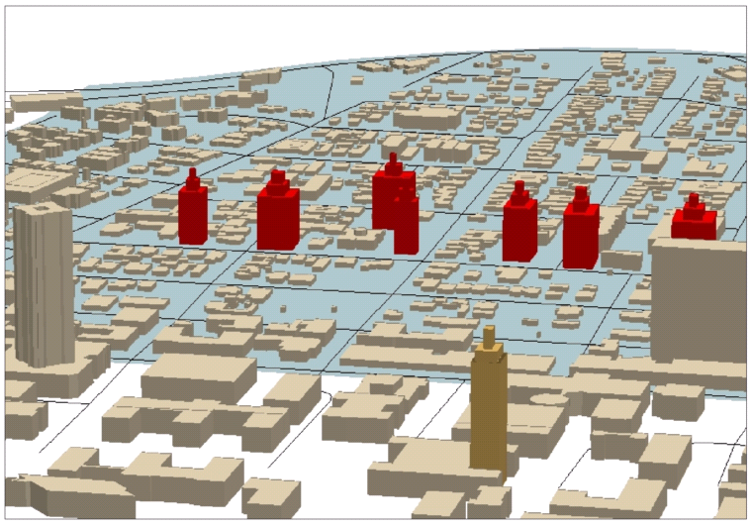
Figure 1. PERMANENT SPREADING IRON CURTAIN: An over 100 year eclectic, historic West Campus legacy and UT-Austin heritage will be bulldozed and paved-over forever. The undersized, diminutive rendition of the red, dark 175 ft Iron Curtain skyscrapers between Dobie (left) and Castilian (right) forewarn a much worse spreading forward towards “the Drag” and the UT Tower (front-center) of the Iron Curtain within the grayish-blue ground area. Note: Some skyscrapers represent already sold/pending properties.
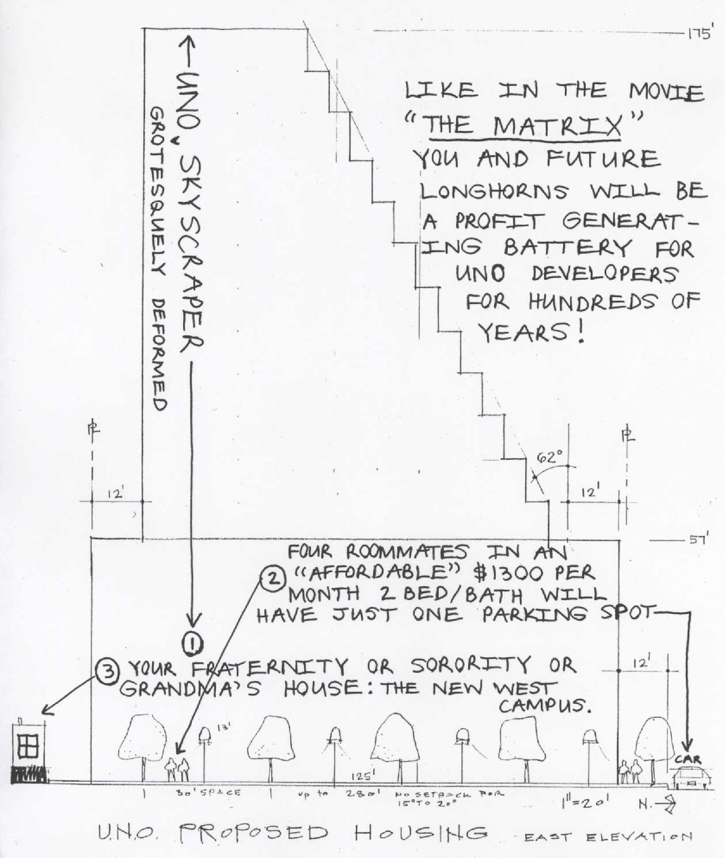
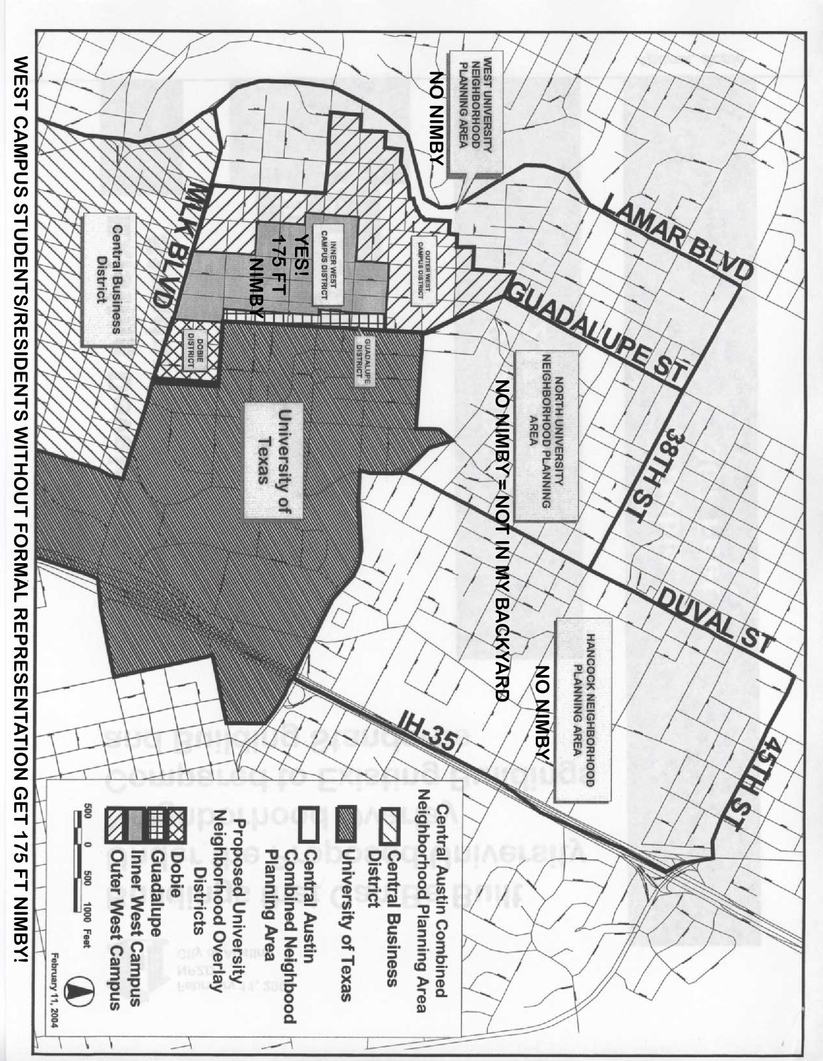
THE PAVING OF A WATERSHED: Temporal Analysis of Impervious Cover on the University of Texas at Austin Campus. (Abridged Summary)

INTRODUCTION: Nature repeats its pattern again and again on different scales. The brain has a network of neurons, the body of veins. Branches and limbs on a tree replicate again in the opposite direction as roots. Land that is circumscribed by a root-like networking pattern of creeks, runs, brooks, branches, arroyos, gulches, ditches, bayous, channels or streams is called a watershed.
Watersheds provide biodiverse, riparian habitats for plants and animals. Their drainage networks create rivers, ponds and lakes. Watersheds are places of natural beauty and sources of drinking water. However, regardless of location, the primary threat to watershed quality and health is watershed development.

ANALYSIS OF TRANSFORMATION FROM 1880 TO 1997* (PLEASE SEE ALL FIVE MAPS)

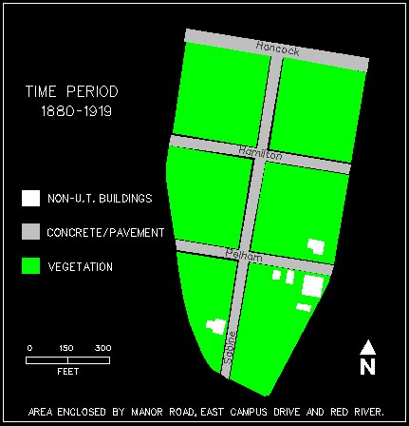  Between 1880 to 1919, the area contained primarily vegetative ground cover and six non-university buildings. The major impervious cover of the time was the four roads Hancock, Hamilton, Pelham, and Sabine. |  |  | 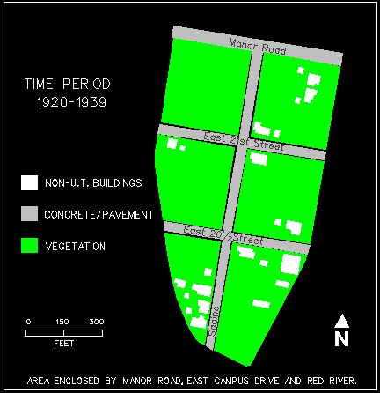  From 1920 to 1939 the number of non-university buildings grew to 23, and Hancock, Hamilton and Pelham became Manor, East 21st Street, and East 20 1/2 Street, respectively.
CONCLUSION: The study section of the University of Texas at Austin campus is encompassed by Manor Road, East Campus Drive and Red River. Now known as the area C parking lot, it is an extreme example of the paving of a watershed. Between 1880 to 1919, the area contained primarily vegetative ground cover and six non-university buildings. The major impervious cover of the time was the four roads Hancock, Hamilton, Pelham, and Sabine. From 1920 to 1939 the number of non-university buildings grew to 23, and Hancock, Hamilton and Pelham became Manor, East 21st Street, and East 20 1/2 Street, respectively. During the time of 1940 to 1959, development extending into the area decreased the vegetative ground cover as 73 non-university buildings and a swimming pool were constructed. The addition of the first parking lot at this time period was the turning point for the area from a residential section of student apartment buildings to its present state. Soon after, between 1960 and 1989, all the houses and apartments west of Sabine were demolished for more parking spaces. Finally, from 1990 to 1997 the remaining 21 non-university buildings to the east of Sabine were replaced with pavement. As a result of the slope of the adjoining area toward Waller Creek and the near zero permeability, elevated levels of runoff enter the watershed due to this transformation from vegetative ground cover to parking lots.
The paving or development of a watershed is linked to declines or disruptions in coral reefs, salmon runs, freshwater mussel biodiversity, sea grass beds, endangered salamanders habitats, shellfish harvests and trout streams. More research must be conducted to determine the effectiveness of methods or techniques to reduce the negative impact of watershed development including but not limited to land conservation, aquatic buffers, watershed planning, erosion controls, better site design, grey water discharge, stormwater treatment and watershed stewardship.
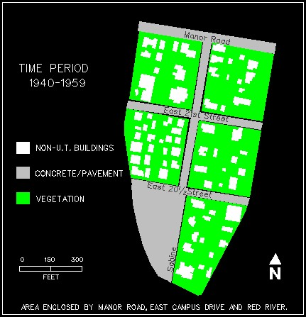  During the time of 1940 to 1959, development extending into the area decreased the vegetative ground cover as 73 non-university buildings and a swimming pool were constructed. The addition of the first parking lot at this time period was the turning point for the area from a residential section of student apartment buildings to its present state. | 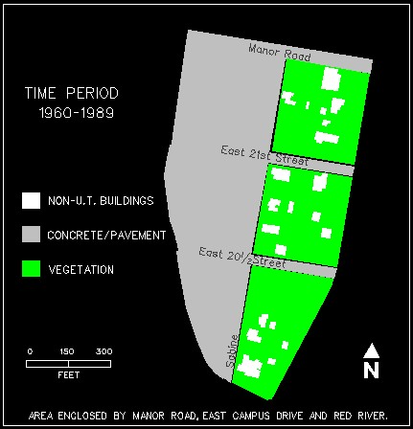  Soon after, between 1960 and 1989, all the houses and apartments west of Sabine were demolished for more parking spaces.
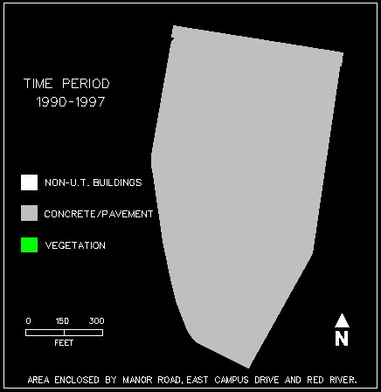 |  | 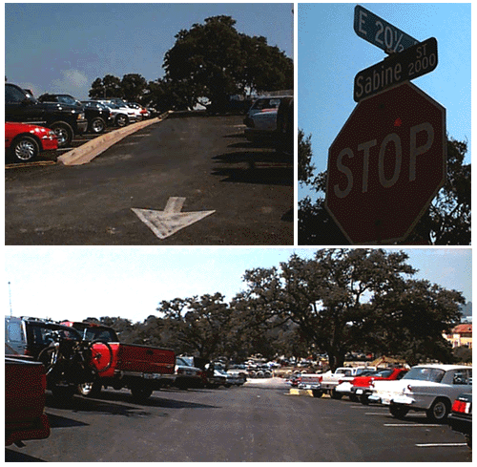
Finally, from 1990 to 1997 the remaining 21 non-university buildings to the east of Sabine were replaced with pavement. As a result of the slope of the adjoining area toward Waller Creek and the near zero permeability, elevated levels of runoff enter the watershed due to this transformation from vegetative ground cover to parking lots.

*All data were collected from the Sanborn Map Collection and reproduced by free hand and heads-up digitizing using Microstation; therefore, a 1 to 3 foot error in coordinates should be expected.

